# Buggy Rating Link

Description: Buggy Rating (Home link) link at the top of the following page are broken

Steps:

1. Open the [https://buggy.justtestit.org](https://apac01.safelinks.protection.outlook.com/?url=https%3A%2F%2Fbuggy.justtestit.org%2F&data=04%7C01%7C%7C191bef54a16e472e25bc08d97e6a2863%7C84df9e7fe9f640afb435aaaaaaaaaaaa%7C1%7C0%7C637679816683752754%7CUnknown%7CTWFpbGZsb3d8eyJWIjoiMC4wLjAwMDAiLCJQIjoiV2luMzIiLCJBTiI6Ik1haWwiLCJXVCI6Mn0%3D%7C1000&sdata=sry0xpc3eaT5Xydz3VraSSLToR0vEiT9tQqEEBfVHjE%3D&reserved=0)

2. Navigate to the following pages and try to click the Bug Rating to navigate back to the home page

|  |  |  |
| --- | --- | --- |
|  |  |  |
|  | Popular Make/ Lamborghini page | <https://buggy.justtestit.org/make/c4u1mqnarscc72is00e0> |
|  | Pagani Page | <https://buggy.justtestit.org/make/c4u1mqnarscc72is00tg> |
|  | Alfa Romeo | <https://buggy.justtestit.org/make/c4u1mqnarscc72is00ng> |
|  | Lancia | <https://buggy.justtestit.org/make/c4u1mqnarscc72is013g> |
|  | Pagani | <https://buggy.justtestit.org/make/c4u1mqnarscc72is00tg> |
|  | Bugatti | <https://buggy.justtestit.org/make/c4u1mqnarscc72is0100> |

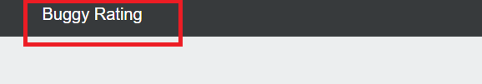

Expected result: user should be able to navigate back to the home page

Actual result: the user is not able to navigate. They have to use the browser back button

# Sorting functionality on all the Model Page

Description: Sorting functionality on all the Model Page (Lamborghini page, Pagani page, Alfa Romeo page, Lancia page, Pagani page, and Bugatti page) for all columns are not working correctly.

Steps:

1. Open the [https://buggy.justtestit.org](https://apac01.safelinks.protection.outlook.com/?url=https%3A%2F%2Fbuggy.justtestit.org%2F&data=04%7C01%7C%7C191bef54a16e472e25bc08d97e6a2863%7C84df9e7fe9f640afb435aaaaaaaaaaaa%7C1%7C0%7C637679816683752754%7CUnknown%7CTWFpbGZsb3d8eyJWIjoiMC4wLjAwMDAiLCJQIjoiV2luMzIiLCJBTiI6Ik1haWwiLCJXVCI6Mn0%3D%7C1000&sdata=sry0xpc3eaT5Xydz3VraSSLToR0vEiT9tQqEEBfVHjE%3D&reserved=0)

2. Navigate to the following pages and try to use the Sort functionality by clicking the column heading

|  |  |  |
| --- | --- | --- |
|  |  |  |
|  | Popular Make/ Lamborghini page | <https://buggy.justtestit.org/make/c4u1mqnarscc72is00e0> |
|  | Pagani Page | <https://buggy.justtestit.org/make/c4u1mqnarscc72is00tg> |
|  | Alfa Romeo | <https://buggy.justtestit.org/make/c4u1mqnarscc72is00ng> |
|  | Lancia | <https://buggy.justtestit.org/make/c4u1mqnarscc72is013g> |
|  | Pagani | <https://buggy.justtestit.org/make/c4u1mqnarscc72is00tg> |
|  | Bugatti | <https://buggy.justtestit.org/make/c4u1mqnarscc72is0100> |

Expected Result: The item in the list will be sorted

Actual result: The item is not sorted correctly

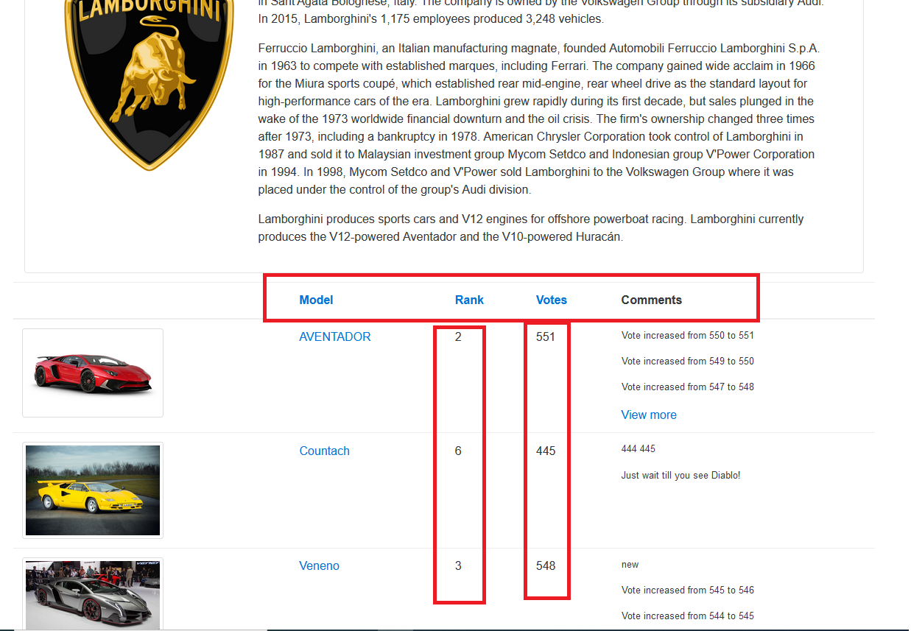

# Registration Form invalid password error message

The error message in the form is not concise and friendly error message for invalid passwords. Also, it will be nice if their password policy guide. The following example is a possible password policy that you can create.

* Minimum of 6 characters in length
* Maximum of 10 characters in length
* Must have at least two special characters

# Registration Form if the user already exists an error message

The error message in the form is not concise and friendly because the user (login name) already exists in the system.

# Registration form first name and last name validation

Description: The is no validation in place for Frist name and last name. Ther is no maximum length validation for Frist name and last name in place

1. Open the [https://buggy.justtestit.org](https://apac01.safelinks.protection.outlook.com/?url=https%3A%2F%2Fbuggy.justtestit.org%2F&data=04%7C01%7C%7C191bef54a16e472e25bc08d97e6a2863%7C84df9e7fe9f640afb435aaaaaaaaaaaa%7C1%7C0%7C637679816683752754%7CUnknown%7CTWFpbGZsb3d8eyJWIjoiMC4wLjAwMDAiLCJQIjoiV2luMzIiLCJBTiI6Ik1haWwiLCJXVCI6Mn0%3D%7C1000&sdata=sry0xpc3eaT5Xydz3VraSSLToR0vEiT9tQqEEBfVHjE%3D&reserved=0)

2. Navigate to the registration page and try to register

3. Enter the login name, enter 50 charter in the first and last names, enter the password, and save.

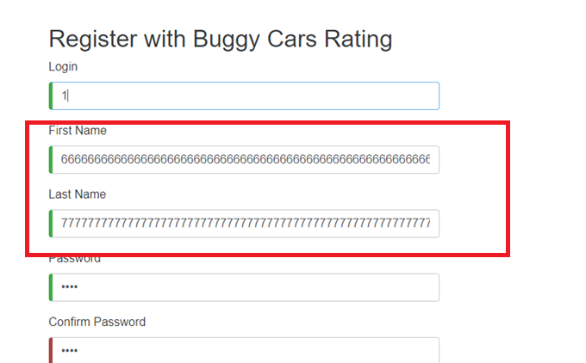

Expected Result: The system will have a validation rule that will only allow the user to enter the specific length of the first name and last name

Actual Result: Their no validation, so when the user enters a long name, it does look good when displayed on the home page

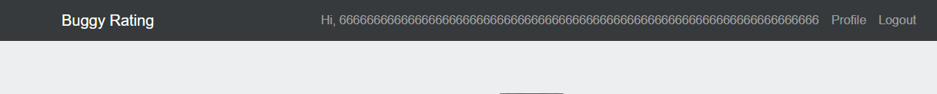

# Profile Form, username update are not refresh from the home page

When users update their name and successfully save from the profile page, the user name on the home page is not refreshed. It still shows the old name. The user has to logout and login to see the changes

Navigate home page



Logout and login

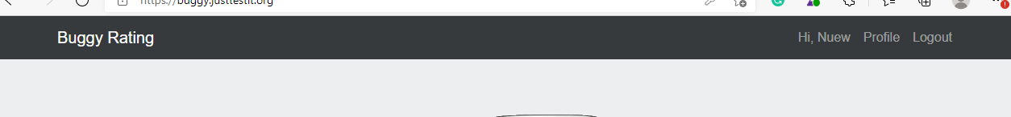

# Profile form page age field error message

When the user tries to update the age, and they enter invalid input, the error message in the form is the concise and friendly error message

# Ypsilon image is **missing**

Descriptions: Ypsilon image is missing on the following pages

* Overall rating page 5

* Ypsilon page

<https://buggy.justtestit.org/model/c4u1mqnarscc72is013g%7Cc4u1mqnarscc72is0150>

